# Ideation Phase Brainstorm & Idea Prioritization Template

|  |  |
| --- | --- |
| Date | 02 November 2025 |
| Team ID | NM2025TMID07661 |
| Project Name | Streamlining Ticket Assignment for Efficient Support Operation |
| Maximum Marks | 4 Marks |

## Brainstorm & Idea Prioritization Template:

Our team brainstormed ideas to improve the ticket assignment process and reduce delays in support operations. Everyone shared creative solutions to make task distribution faster and more balanced. After discussion, the best ideas were selected to build an efficient and automated system for support management.  
**Reference:** <Streamlining Ticket Assignment for Efficient Support Operations>

## Step-1: Team Gathering, Collaboration and Select the Problem Statement

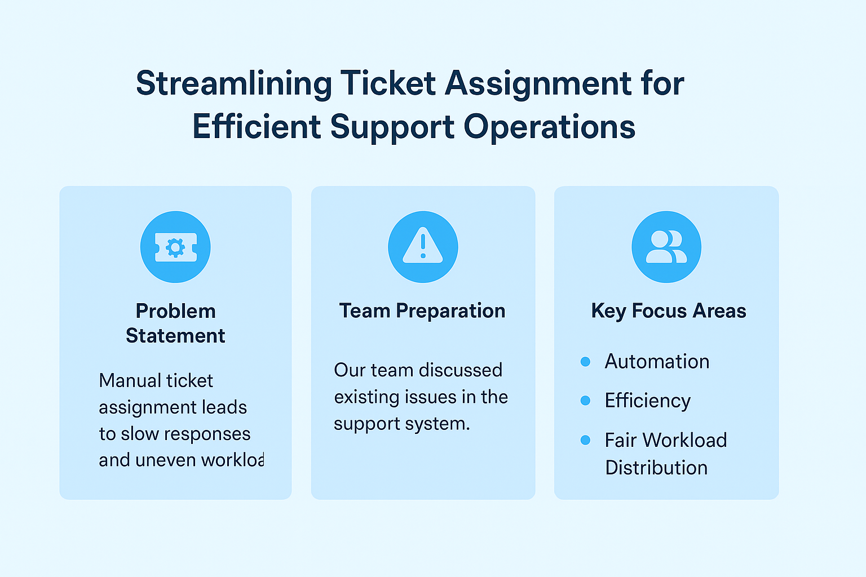

## Step-2: Brainstorm, Idea Listing and Grouping

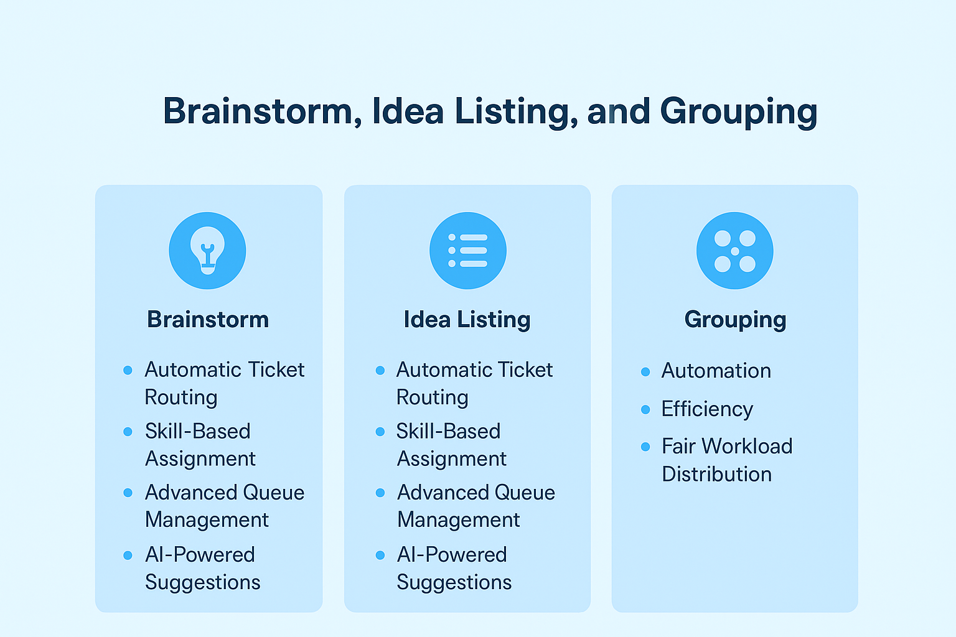

## Step-3: Idea Prioritization

